**Student Grade Report**

­­

|  |  |  |  |  |  |  |  |  |  |  |  |  |  |  |
| --- | --- | --- | --- | --- | --- | --- | --- | --- | --- | --- | --- | --- | --- | --- |
| ­ | | | Post-Test | | | Short Quiz | | | Long Quiz | | | Major Exam | | |
| TOPICS | SUB TOPICS | C | IN | Grade | C | IN | Grade | C | IN | Grade | C | I­N | Grade | C | IN | Grade |
| 1. Introduction to Accounting | Day 1 Define Accounting |  |  |  |  |  |  |  |  |  |  |  |  |  |  |  |
| Day 2 Describe the nature of Accounting |  |  |  |  |  |  |  |  |  |  |  |  |  |  |  |
| Day 3 Explains the function of accounting in business |  |  |  |  |  |  |  |  |  |  |  |  |  |  |  |
| Day 4 narrate the History/ origin of Accounting |  |  |  |  |  |  |  |  |  |  |  |  |  |  |  |
| 1. Branches of Accounting | Day 5 Differentiate the branches of Accounting |  |  |  |  |  |  |  |  |  |  |  |  |  |  |  |
| Day 6 Explain the kind/Type of services rendered in each of these branches |  |  |  |  |  |  |  |  |  |  |  |  |  |  |  |
| 1. Users of Accounting information | Day 7 define external users and give examples |  |  |  |  |  |  |  |  |  |  |  |  |  |  |  |
| Day 8 define internal users and give examples |  |  |  |  |  |  |  |  |  |  |  |  |  |  |  |
| Day 9 identify the type of decisions made by each group of users |  |  |  |  |  |  |  |  |  |  |  |  |  |  |  |
| Day 10 describe the type of information needed by each group of users |  |  |  |  |  |  |  |  |  |  |  |  |  |  |  |
| 1. Forms of Business organizations | Day 11 differentiate the forms of business organization |  |  |  |  |  |  |  |  |  |  |  |  |  |  |  |
| Day 12 identify the advantages and disadvantages of each form |  |  |  |  |  |  |  |  |  |  |  |  |  |  |  |
| 1. Types of Business according to Activities | Day 13 compare and contrast the types of business according to activities |  |  |  |  |  |  |  |  |  |  |  |  |  |  |  |
| Day 14 identify the advantages, disadvantages, and business requirements of each type ABM |  |  |  |  |  |  |  |  |  |  |  |  |  |  |  |
| 1. Accounting Concepts and Principles | Day 15 explain the varied accounting concepts and principles |  |  |  |  |  |  |  |  |  |  |  |  |  |  |  |
| Day 16 solve exercises on accounting principles as applied in various cases |  |  |  |  |  |  |  |  |  |  |  |  |  |  |  |
| 1. The Accounting Equation | Day 17 illustrate the accounting equation |  |  |  |  |  |  |  |  |  |  |  |  |  |  |  |
| Day 18 perform operations involving simple cases with the use of accounting equation |  |  |  |  |  |  |  |  |  |  |  |  |  |  |  |



Send Email to:

* + - Teacher
    - Parent/Guardian
    - Guidance



New message:

Email:

Johnnyyespapa123@rocketmail.com

Subject:

I got a perfect score

Hi sir





SEND

Create a Session

* Study Session
* Test Session
* Continue Last Session



Create Study Session

Select Course/Subject



* ABM Applied Economics
* ABM Business Ethics and Social Responsibility
* ABM Business Finance
* ABM Business Math
* ABM Culminating Activity Business Enterprise Simulation
* ABM Fundamentals of Accountancy, Business and Management 1
* ABM Fundamentals of Accountancy, Business and Management 2
* ABM Organization and Management
* ABM Principles of Marketing

Please click settings:

* Recommended
* Customized

Cancel

NEXT



Create Test Session

Cancel

Next

Select Course/Subject



* ABM Applied Economics
* ABM Business Ethics and Social Responsibility
* ABM Business Finance
* ABM Business Math
* ABM Culminating Activity Business Enterprise Simulation
* ABM Fundamentals of Accountancy, Business and Management 1
* ABM Fundamentals of Accountancy, Business and Management 2
* ABM Organization and Management
* ABM Principles of Marketing

Please click settings:







Create Study Session

*Select Topics*

⊖ Topic 1 Introduction to Accounting

Day 1: Accounting Definition

Day 2: Nature of Accounting

Day 3: Function of Accounting in Business Organization

Day 4: History/Origin of Accounting

⊖Topic 2 Branches of Accounting

Day 1: Branches of Accounting

Day 2: Kind of business rendered in each of these Branched

* Topic 3 Users of Accounting information
* Topic 4 Forms of Business organizations
* Topic 5 Types of Business according to Activities
* Topic 6 Accounting Concepts and Principles
* Topic 7 The Accounting Equation

Help

Select all

Cancel

Next

Previous



Create Test Session

Topic 1 Introduction to Accounting

Day 1: Accounting Definition

Day 2: Nature of Accounting

Day 3: Function of Accounting in Business Organization

Day 4: History/Origin of Accounting

* Topic 2 Branches of Accounting

Day 5: Branches of Accounting

Day 6: Kind of business rendered in each of these Branched

* Topic 3 Users of Accounting information
* Topic 4 Forms of Business organizations
* Topic 5 Types of Business according to Activities
* Topic 6 Accounting Concepts and Principles
* Topic 7 The Accounting Equation

*Select Topics*





ExcelCIA

SHS-ABM



­

Help

Select all

Cancel

Next

Previous



Create Test Session

*Select Order*

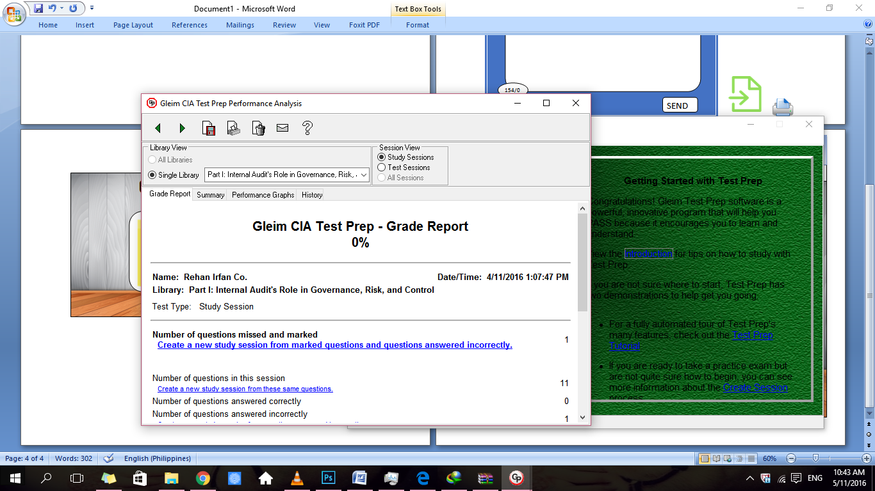

Learning v.1



Session Grade Tools Help